# Project Proposal

JATIN MAHAJAN

# Project Introduction and Goal

Tony want to extend the business by bringing it online. He want to sell his products on an international level by creating a website.

# Client Details

|  |  |
| --- | --- |
| **NAME** | Tony Stark |
| **CONTACT** | .02041544103 |
| **ADDRESS** | 1 hooker place Auckland |
| **E-MAIL** | jm@gmail.com |

# Project Description

## Project Need

A website that display the product that can be added to the website by the admin in the admin panel. The contact page which is linked to the admin panel customer. Customer can contact tony by using contact feature.

## Goals and Objectives

The main goal of this website is to attract customer that cannot visit the tony’s shop or the customer to whom get their products home delivered.

The website allows: -

* The customers to order products in their conform of home
* Tony can add products that are shown to the people who visit his website
* Customers to contact tony using contact page.

## Languages used: -

* .Net framework
* C Sharp
* ASP.net
* Bootstrap
* MYSQL

## Target Audience

The main target of this project are people who can’t come tony’s shop. They can place their order using the website that I am creating

## Out of Scope: -.

Search bar to search products

A filter mechanism to filter the products

## Project Deliverable: -

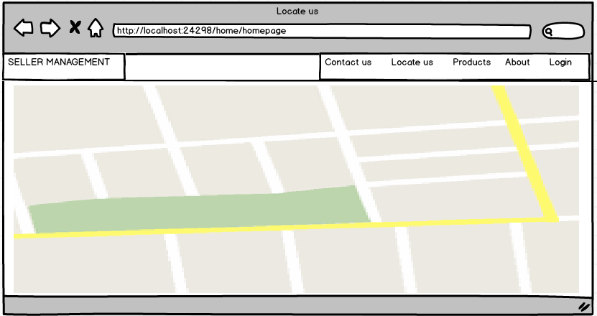

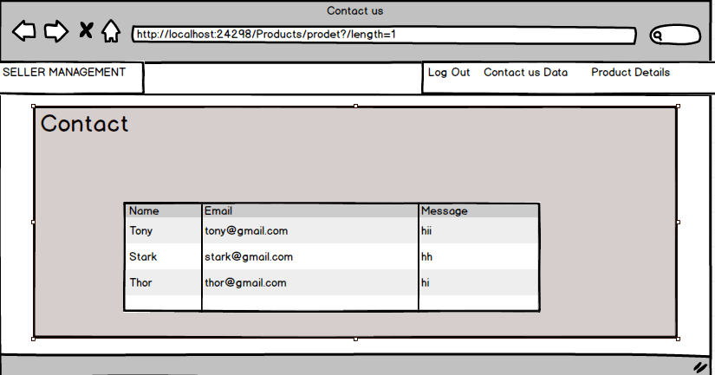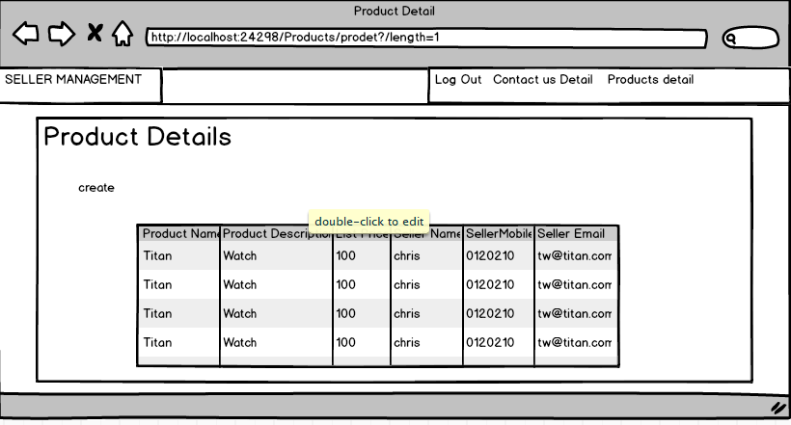

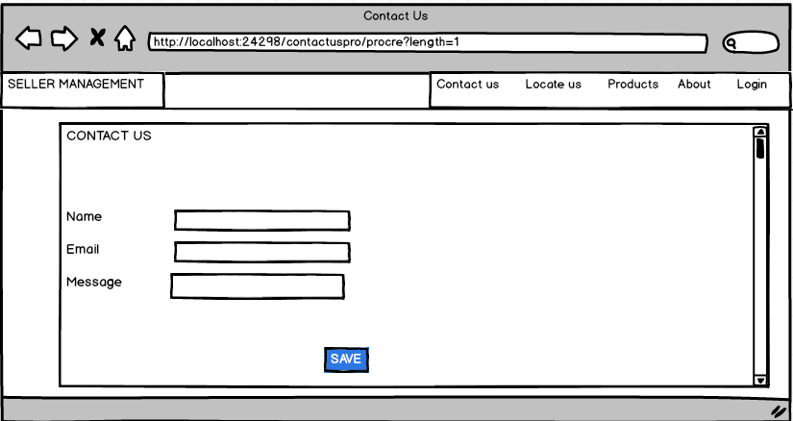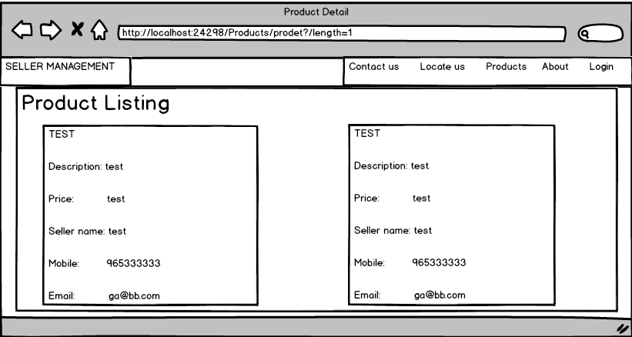

**Features of website in detailing**

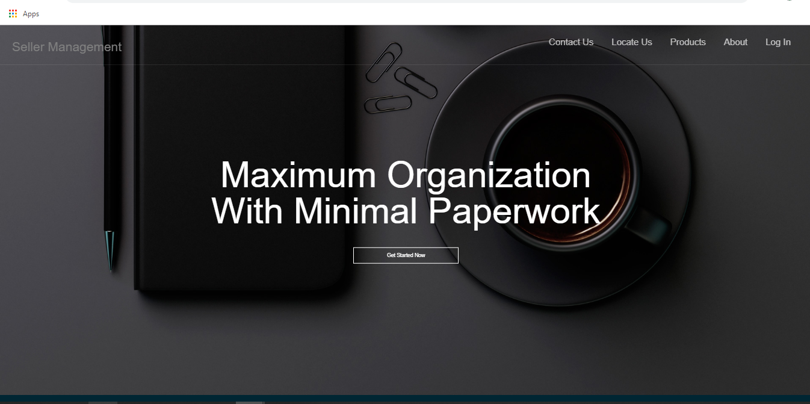

**This is the front page of the website which contains five more pages.**

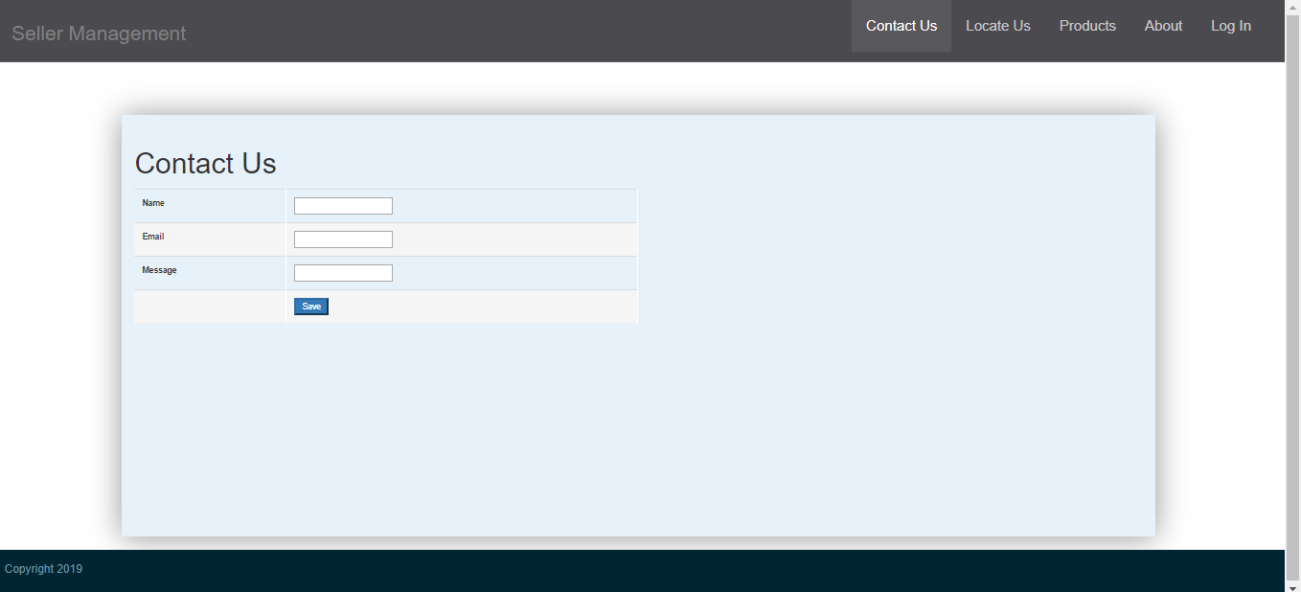

**The contact us page show the contact form where customer can directly contact to the tony.**

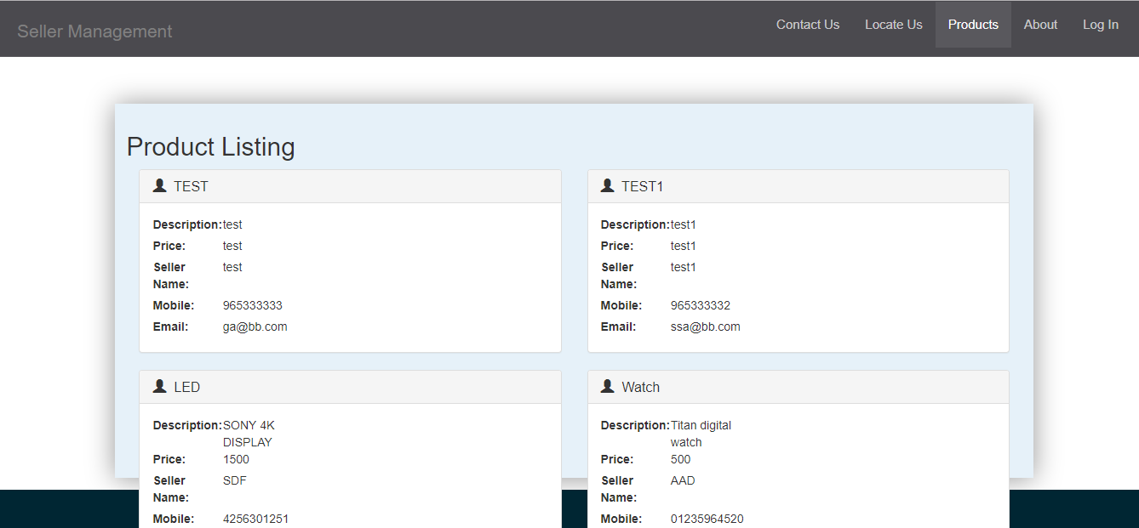

**The product listing page show the product which will be added by the admin and it can also be deleted by the admin.**

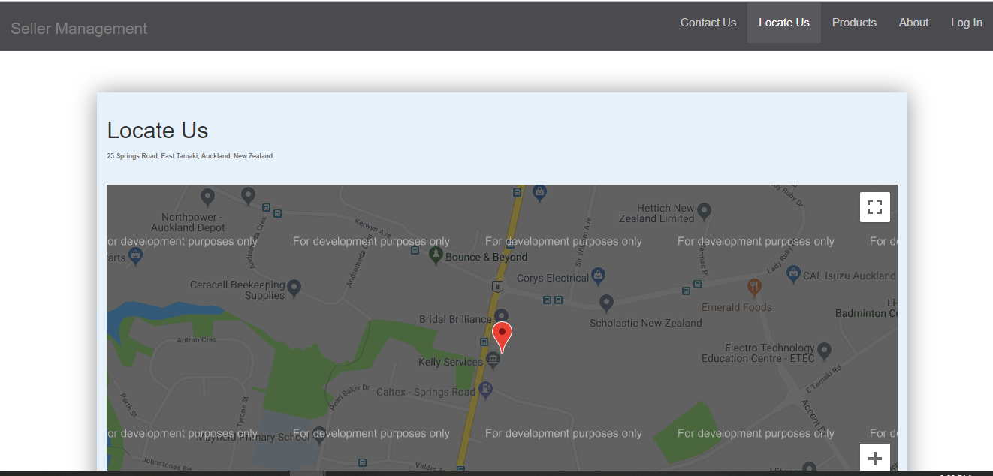

**It will help to locate the shop for customer, they can easily find the shop by locate it.**

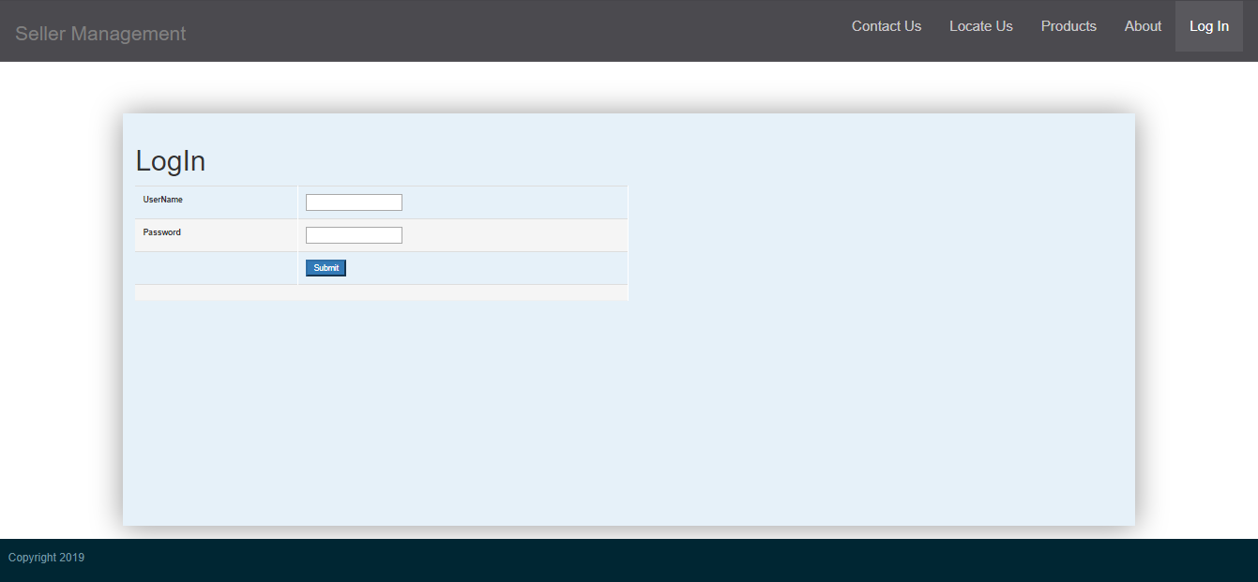

**The login form is for admin, admin can login by enter username and password for checking who has contact him or for adding product.**

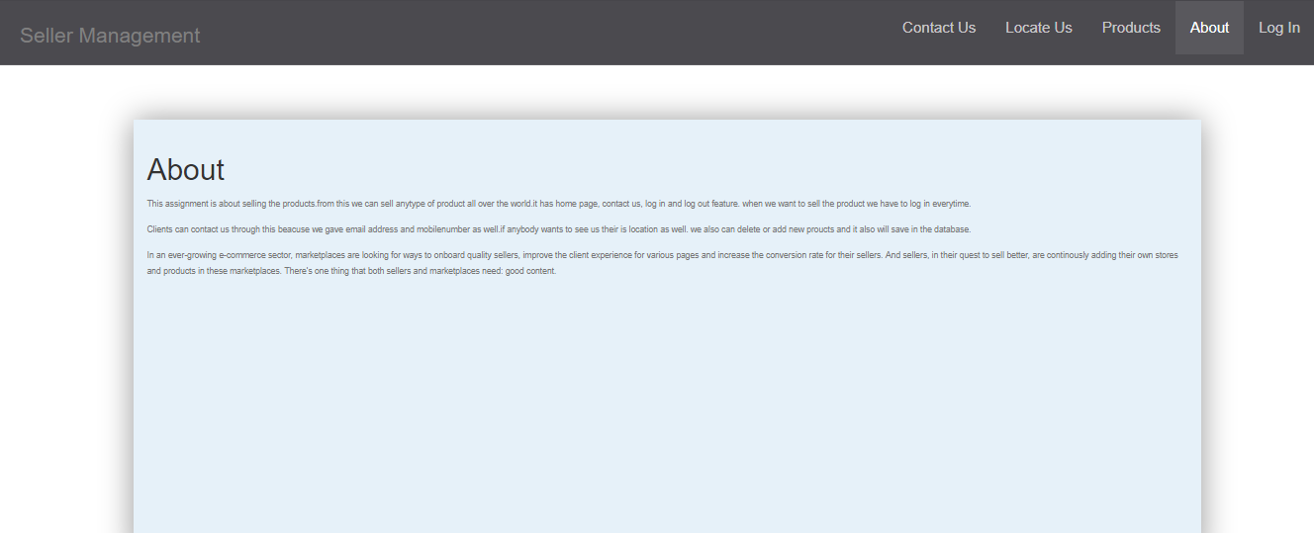

**In this page we come to know about the features of the project.**

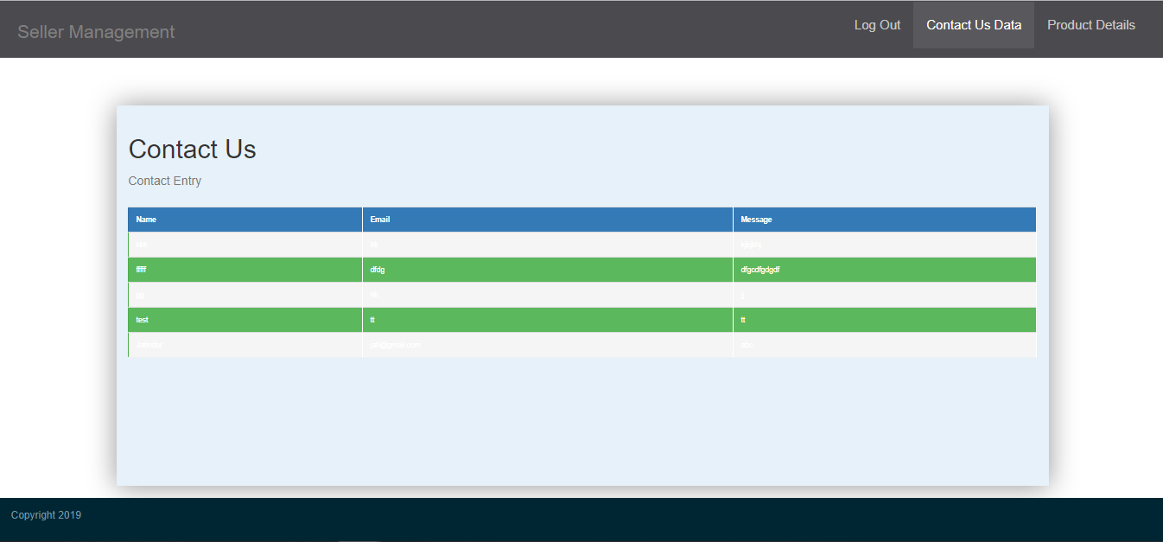

**It will helps to tony to know who had contact him. It like call the details and its like feedback feature for the shop.**

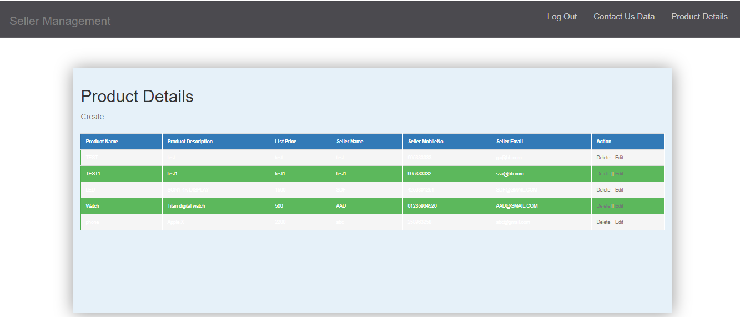

**This page help to add new products and delete the products. Tony can also edit his products.**

## Quality Plan: -

|  |  |  |  |  |  |
| --- | --- | --- | --- | --- | --- |
| Step NO | Test Step | Input Data | Expected Result | Actual Result | Test Step Result |
| 1 | Add new product | watch | Product should be added in product page | As Expected | Pass |
| 2 | Log in system | Login | Log in page should working | As Expected | Pass |
| 3 | Contact us page | Maria | Contact us page should working | As Expected | Pass |
| 4 | Delete Button in product  table | watch | Product should be deleted | As Expected | Pass |
| 5 | Product shown | LED | Product listing should shown in product tab | As Expected | Pass |

## Project executive summary: -

**Hardware: -**

* Windows 10
* Intel core processor i5
* 8GB RAM

**Software: -**

* Visual Studio 2017
* Microsoft SQL

**Languages: -**

* C Sharp
* jQuery
* ASP.Net
* SQL

## Resources: -

Requirements Required to complete this project are as follow:

* PC must have RAM of 8GB.
* Windows used should be Windows 10.
* At least Intel i5 Processor should be used.
* Visual Studio 2017 is Required for the coding.
* Microsoft SQL is required for establishing the database and for the connection between visual studio and database.
* C#, jQuery, bootstrap, HTML, NETFramwork, ASP, all of them should be used.

## Project Milestone: -

|  |  |
| --- | --- |
| **WORK** | **DAY** |
| Database | 15 April to 17 April |
| Controller | 18 April to 20 April |
| Front End | 21 April to 24 April |
| Back End Coding | 26 April to 29 April |
| Documentation | 30 April to 02 May |

## Project Schedule: -

|  |  |
| --- | --- |
| **WORK** | **HOURS** |
| **Database** | **4.5 hours** |
| **Controller** | **12 hours** |
| **Front End** | **9 hours** |
| **Back End Coding** | **19 hours** |
| **Documentation** | **2 hours** |